Project Design Phase
Solution Architecture

Date | 15 February 2025
Team ID | LTVIP2026TMIDS38821
Project Name | Exploratory Analysis of Rain Fall Data in India for Agriculture
Maximum Marks | 4 Marks

Solution Architecture:
The Exploratory Rainfall Prediction System follows a modular, three-tier solution architecture that bridges the gap between agricultural decision-making and AI-based predictive analytics.
The architecture ensures:
- Scalable deployment
- Reliable rainfall data processing
- Accurate ML-based prediction results
- Clear separation of frontend, backend, and data components
- Easy integration with future APIs and cloud services
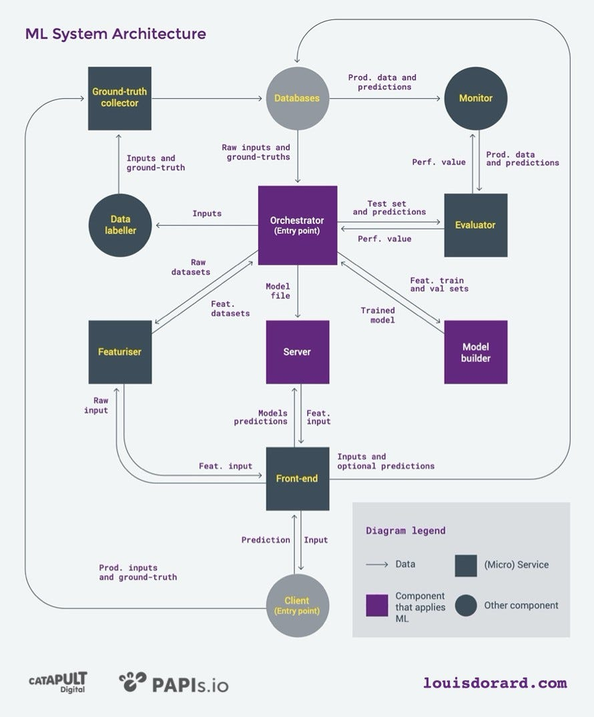
Solution Architecture Diagram:

Figure 1: Solution Architecture and Data Flow of the Exploratory Rainfall Prediction System
Reference: AWS Architecture Design Considerations –
https://aws.amazon.com/blogs/industries/

